Guised Up
Take-HomeTechnicalProject
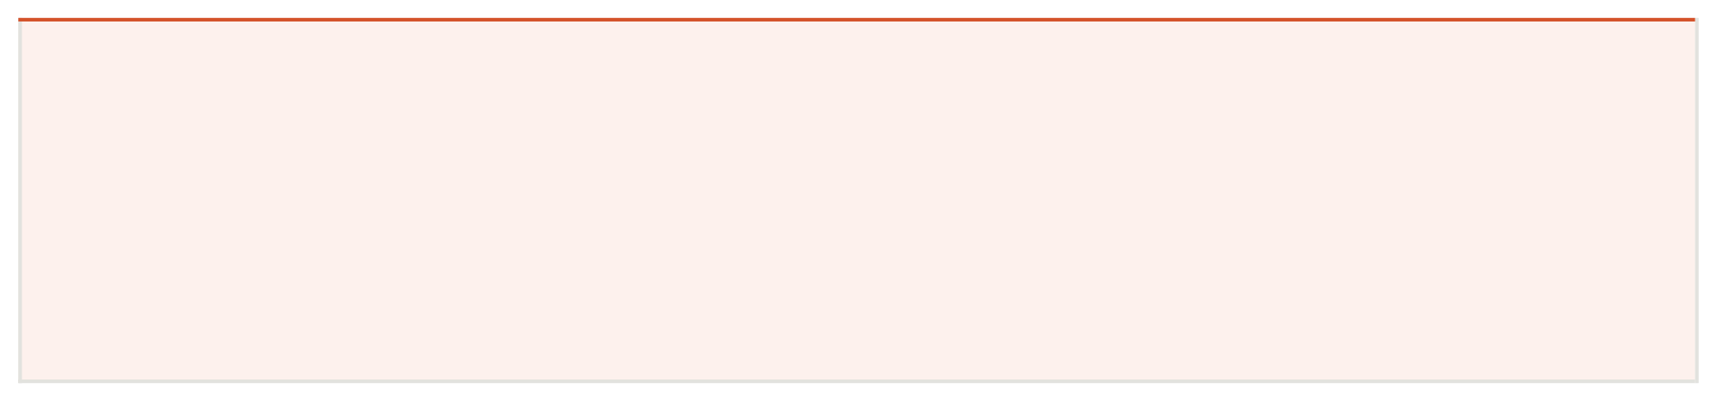
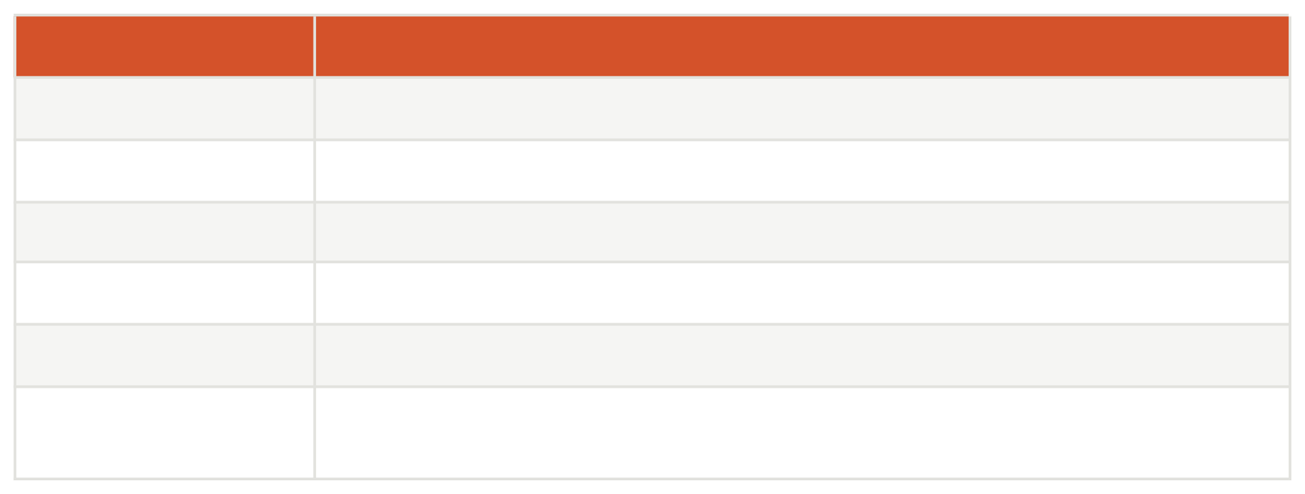
Full-Stack Developer Assessment

Before you start, read this.
Thisproject isdesigned to reveal how you think, not just what you know. There are intentionally open-ended sections. A senior engineer will read your technical solution doc as carefully as your code. Don't just build — explain your decisions.
Time: 1 full day (8 hours). You are expected to use AI agentic tools. Not using them will be a red flag.
FRioelled
Stack
Details
Full-Stack Developer
Time Limit
React Native • Laravel PHP • Python • SQL • Vector DB
Submission
1 day
AI Tools
GitHub repo + solution doc (PDF or Notion link)
Contact
Required — Cursor, Copilot, Claude, etc.
DM founder on LinkedIn/ whatsapp the number from where you received this
if you have blockers

The Context
Guised Up is a social platform being built to help people show up authentically online — no curated highlight reels, no follower-count anxiety. Real people, real connections.

You're joining as a founding engineer. This isn't a CRUD exercise. We want to see how you think when given a real product problem.

The app is a React Native mobile application with a Laravel PHP + Python backend, SQL databases, and vector DB for intelligent search and recommendations. You are expected to work fast — using AI agentic tools to reach 80%+ efficiency.

The Product Brief

Read this carefully. Your technical solution doc will be evaluated on how well you comprehend and respond to this brief.

Feature: Real Connections Feed
Guised Up needs a personalized "RealConnections" feed. Unlike Instagram or Twitter, this feed should NOT rank content by engagement metrics (likes, shares, comments). Instead, it should rank content by:
•

•

•

•
Authenticity signals — posts with fewer filters, less-polished images, and genuine text get ranked higher
Relationship depth — content from people you interact with genuinely (not just follow) surfaces first
Semantic similarity — the feed understands what topics you care about using vector embeddings
Time decay — newer content is preferred, but not at the expense of relevance
Users can also search the feed using natural language. For example: "funny travel stories from last week" should return semantically relevant posts — not keyword matches.

What You Need to Build
Complete all 4 parts. Each part tests a different dimension of your skill.


Part A — Technical Solution Document
Before writing a single lineofcode, produce a Technical Solution Document (TSD) for the Real Connections Feed feature described above.
YourTSD must include:
- System architecturediagram (even a rough ASCII/diagram.io sketch is fine)
- Database schemadesign — tables, relationships, indexes
- How you plan to implement vector embeddings and which vector DB you'd use and why
- API design — endpoints, request/response shapes, auth strategy
- Feed ranking algorithm — explain the logic in plain English first, then in pseudocode
- What AI agentic tools you used and how they helped you (be honest — this matters)
- Any trade-offs or assumptions you made
Format: PDF, Notion page, or Markdown in your repo. Length: as long as it needs to be, not a word more.

Part B — Backend API (Laravel PHP + Python)

Build the following API endpoints. Python can be used for ML/embedding tasks; Laravel for the main API layer.


Endpoint
POST /api/posts

GET /api/feed

GET
/api/search?q={query} POST /api/interactions

Requirements:
Description
Create a new post. Accept text + optional image URL. Auto-generate a vector embedding for the post content and store it.
Return a personalized feed for the authenticated user. Use your ranking logic from the TSD. Return paginated results (20 per page).
Natural language search across posts using vector similarity. Return top 10 semantically relevant results.
Log a user interaction (view, reply, reaction) against a post. This feeds the relationship-depth signal.

- Auth: UseLaravel Sanctum (token-based). Seed at least 2 test users.
- SQL: UseMySQL or PostgreSQL. Migrations must be included.
- Vector DB:Useany — Pinecone, Weaviate, pgvector, Qdrant, or Chroma. Explain your choice intheTSD.
- Embeddings:Use any open model (OpenAI, sentence-transformers, etc.) or mock it with a simple hashifyou don't have API credits — just explain the swap.
- Tests: Writeatleast 3 unit or feature tests for your most critical logic.

Part C — React Native Screen
Build a single React Native screen: the Feed Screen.
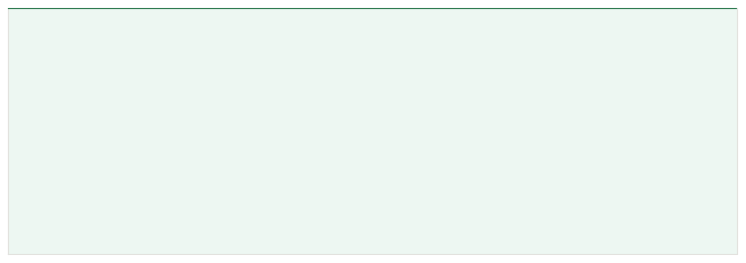

The Feed Screen must:
- Fetch and displaythe paginated feed from your GET /api/feed endpoint
- Each post cardshould show: avatar placeholder, username, post text, time ago, and a reaction button
- Implement infinitescroll (load next page when user reaches bottom)
- Include a searchbar at the top that calls GET /api/search and shows results inline
- Handle loading,empty, and error states gracefully

UI quality matters. It doesn't need to be pixel-perfect, but it should feel intentional. No default React Native styles.

Part D — SQL Challenge
Write raw SQL queries for the following. Include them in a /sql folder in your repo.

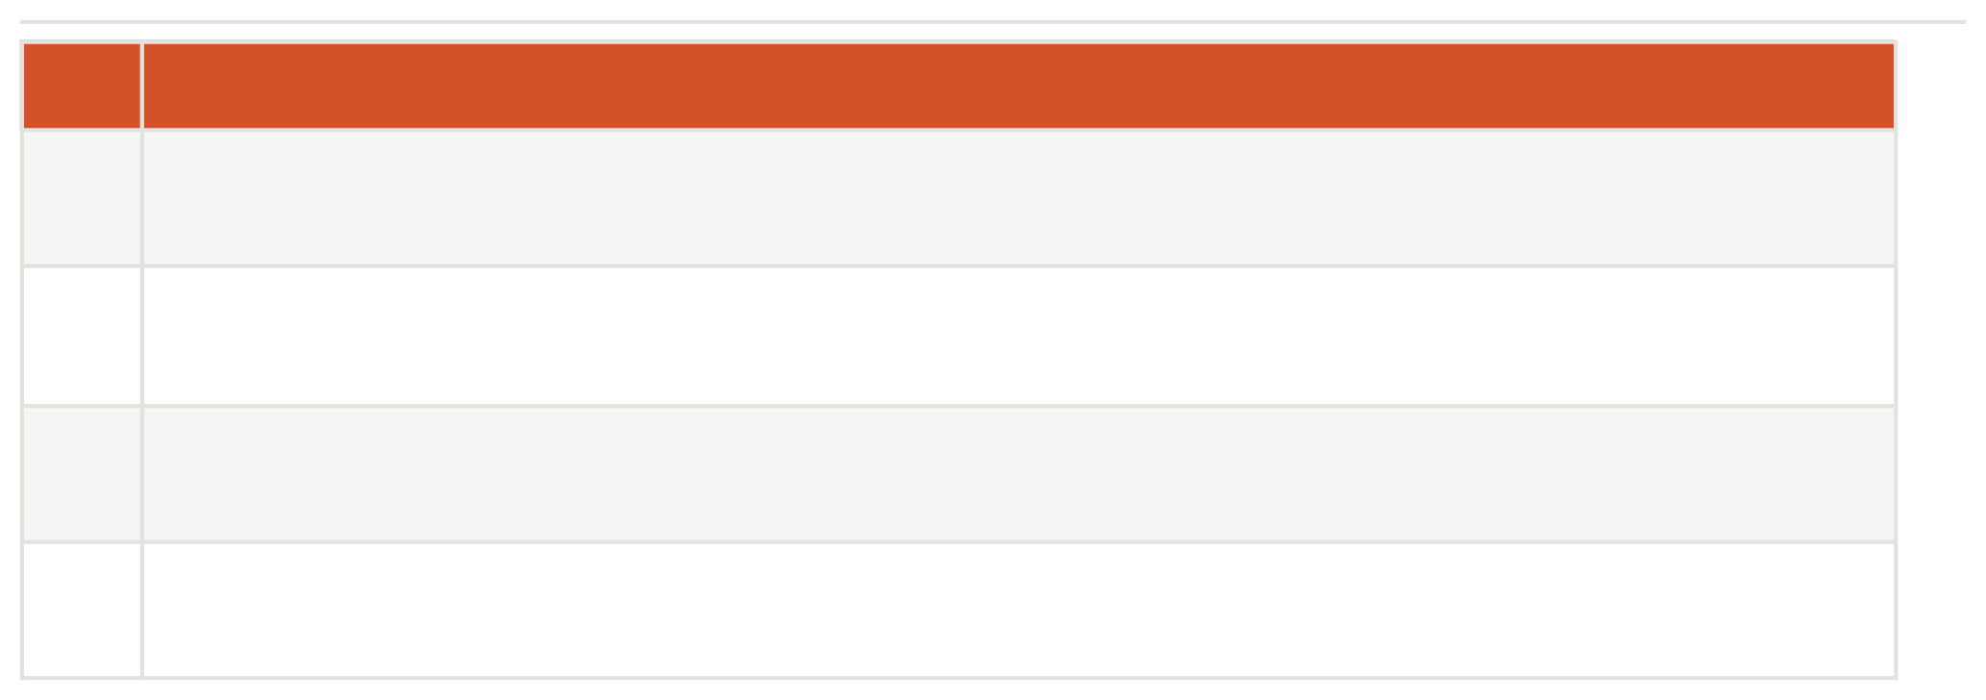
How You’ll Be Evaluated
#D1
Query Required
Return the top 10 most active users in the last 7 days, ranked by total interactions (views + replies + reactions).
D2
For a given user_id, return all posts from users they interact with most, ordered by interaction frequency descending, limited to posts from the last 30 days.
D3
Find any posts that have been viewed more than 100 times but have zero reactions. Return post_id, author_id, view_count, and created_at.
D4
Write a query that would help detect potential spam — users who have created more than 20 posts in the last 24 hours. Include their email and post count.
We score every submission across 5 dimensions. The TSD carries as much weight as the code.

MAKE A VIDEO OF THE END PRODUCT EXPLAINING THE FEATURES

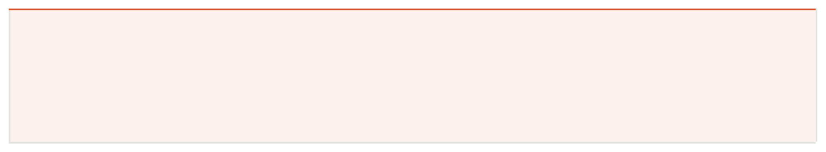
What We Look For
Dimension
Technical Solution Doc
Weight
25%
Does it show deep comprehension of the brief? Are decisions explained clearly?
Backend Quality
25%
Clean architecture, correct SQL schema, working vector search, tests present
React Native Screen
20%
Functional, well-structured, handles edge cases, looks intentiona
l
SQL Queries
15%
Correctness, efficiency, readability — we'll run them against a real DB
AI Tool Usage
15%
Evidence of smart AI-augmented workflow. We want to see you move fast.
Instant disqualifiers
- No TechnicalSolution Document submitted
- Copy-pastedboilerplate with no evidence of understanding
- No migrationsor the DB schema is not reproducible
NO EXPLANATION VIDEO

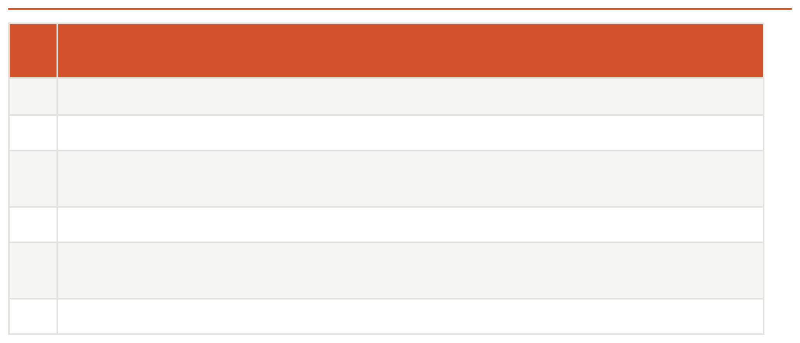
How to Submit

- Plagiarised work — we will check
Ste p
1
Action
Create a private GitHub repo named Guised Up-assessment-[yourname]
2
Push your full code with a clear README (setup instructions, how to run, .env.example)
3
Include your TSD in the repo as /docs/TSD.pdf, /docs/TSD.md, or link a Notion page in your README
Include your SQL queries in /sql/queries.sql
4
Send the GitHub repo link + your TSD link to the founder via LinkedIn DM or the email you
5 received this from
Subject line: [Guised Up Application] Your Name — Full-Stack Assessment
6
Make a video of the app that you build with explanation about features

Rules & Notes
  - You may use any libraries, frameworks, or tools you normally would.
  - You MUST use AI agentic tools (Cursor, GitHub Copilot, Claude, etc.). Document which ones and how in your TSD.
  - You may ask the founder ONE clarifying question via LinkedIn DM. Use it wisely.
  - Do not share this project with anyone else. It is confidential.
  - Partial submissions are acceptable. Submit what you have and explain what you ran out of time for in your README.
  - If you cannot complete the vector DB integration due to API credits, mock it clearly and explain the real implementation in your TSD.

YOU MUST MAKE THE VIDEO WITH EXPLANATION
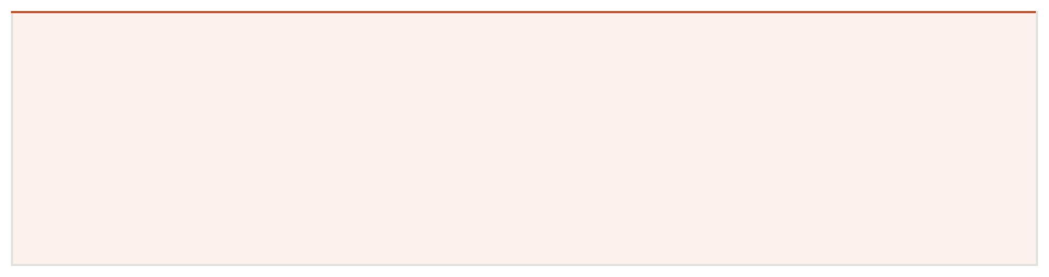

A note from the founder
We designed this project to feel like a real day at Guised Up. You’re given a product brief, expected to think throughthearchitecture, write clean code fast, and explain your decisions clearly. That's the job.
We don't expect perfection.Weexpect hunger, clarity, and evidence that you used every tool available to you to movefastand build well. Good luck — and if you came here with a point to prove, build somethingfrom India to the world, now's your moment.

Guised Up — Building from India, for the world.

